**Autism Spectrum Disorder Detection based on Questionnaire Dataset through Machine Learning Techniques**



**INDIAN INSTITUTE OF INFORMATION TECHNOLOGY, ALLAHABAD**

**A Project Report**

**On**

**“Autism Spectrum Disorder detection”**

**Submitted By:**

**Amardeep**

**Under the Guidance of**

**Prof. Dr. Anupam Agarwal**

**Department of Information Technology**

**1. Abstract**

Autistic Spectrum Disorder (ASD) is a behavioral and neurodevelopmental disorder. It requires significant medical costs and healthcare, and early diagnosis can reduce this disorder significantly. Unfortunately, ASD diagnosis are lengthy, it takes more waiting time for diagnosis and there are very expensive procedures for ASD. There should be an urgent need for the development of effective and easily implemented screening methods for economic and sociological impact of autism and the increased number of ASD cases across the world. Therefore, a time-efficient and accessible ASD screening is important to help health professionals and inform individuals whether they should pursue formal clinical diagnosis. The rapid growth in the number of ASD cases worldwide necessitates behaviour traits related datasets. However, such type of datasets are very rare making it difficult to perform thorough analyses to improve the efficiency, sensitivity, specificity and predictive accuracy of the ASD screening and diagnostic process. Presently, very limited autism datasets associated with clinical or screening are available and most of them are genetic in nature. Hence, we propose a new dataset related to autism screening of adults that contained 18 features to be used for further analysis, especially in determining influential autistic traits and improving the classification of ASD cases. In this dataset, we have ten behavioural features (AQ-10-Adult) plus ten individuals characteristics features that have proved to be effective in detecting the ASD cases from controls in behaviour science.

**2. Introduction**

Autism spectrum disorder is a behavioral and neurodevelopmental disorder that affects a person’s interaction, communication and learning skills. Although diagnosis of autism can be done at any age, its symptoms generally appear in the first two years of life and grows through time. Autism patients face various types of challenges such as learning disabilities, difficulties with concentration, motor difficulties mental health problems such as anxiety, depression etc, sensory problems and many others.

ASD is increasing at a very high rate and Current explosion rate of autism around the world are numerous. About 1 out of every 160 children has ASD according to WHO. Some people with this disorder require life-long care and support while some can live independently.

The objective of this work is to propose an autism prediction model using ML techniques and Algorithms that could effectively predict autism symptoms of a person of any age. In other words, this work focuses on developing an autism screening Model for predicting the ASD traits among people of age groups 4-11 years, 12-17 years and for people of age 18 and more.

**3. Problem Definition and Objective**

With the available ASD dataset on individuals my goal is to make predictions regarding new patients and classify them into one of two categories: “patient does not have ASD ” or “patient has ASD”. In other words, we are working on a binary classification problem with the ultimate goal of being able to classify new instances, i.e. when we have a new adult patient with certain characteristics we would like to be able to predict whether or not that individual has a high probability of having ASD.

We will use supervised machine learning to refer to creating and using models that are learned from data, i.e., there is a set of data labeled with the correct answer for the model to learn from. I will also apply a feature selection algorithm to figure out which of the 19 variables are most important in determining whether an individual has ASD or not.

This work aims to explore several competing supervised machine learning classification techniques namely:

• Decision Trees

• Random Forests

• Support Vector Machines (SVM)

• k-Nearest Neighbors (kNN)

• Logistic Regression

• Multi-Layer Perceptron (MLP)

It also aims to implement the one that proves most effective in terms of correct classification or a combination of classifiers (Ensemble Learning) like Random Forests to arrive at a decision i.e., to identify which patient has ASD or not. All algorithms have been coded using Python and its various packages (like Scikit Learn and Tensorflow with Keras).

**4. Literature Review**

|  |  |  |  |  |  |  |  |  |  |
| --- | --- | --- | --- | --- | --- | --- | --- | --- | --- |
| **Serial no** | **Research paper** | **Author** | **Publishing**  **Date** | **Scope** | **Methodology** | **Dataset**  **used** | **Tools and Techniques** | **Merits** | **Demerits** |
| **[1]** | Applications of Supervised Machine Learning in Autism Spectrum  Disorder Research: a Review | Kayleigh K. Hyde,  Marlena N. Novack,Nicholas LaHaye | 19 February 2019 | Use of supervised machine learning in ASD for classification and text analysis. | Supervised Machine Learning Algorithm | Web-based 15- question Parent survey. | SVM, Random forest, Decision tree,  Logistic regression,  Regularization | Good performance and high accuracy given by Supervised ML algorithms. | Obtaining large amount of dataset is difficult. |
| **[2]** | Video Gesture Analysis for Autism Spectrum Disorder Detection | Andrea Zunino,  Pietro Morerio,  Andrea Cavallo, | September ,2018 | Classification based on video gesture analysis. | LSTM, CNN | Dataset of IRCCS Giannina Gaslini Hospital  and primary schools in Genova. | The Autism Diagnostic Observation Scale (ADOS) and Autism Diagnostic Interview-Revised (ADI-R) | High accuracy and Good performance. | Does not inspect the kinematic discriminants in the gestures. |
| **[3]** | Applying Eye Tracking to Identify Autism Spectrum Disorder in Children | Guobin Wan,  Xuejun Kong,  Binbin Sun,  Yiheng Tu,  Courtney Lang | 10 August  2018 | Classification based on the fixation time at mouth and body. | Apply SVM  on fixation time of AOI(Area-of-interest) | Data is collected from  Shenzhen Maternity & Child Healthcare Hospital  in China. | Gaze patterns were  recorded on a BeGaze data analysis software system. | Discriminate ASD from TD with a classification accuracy of 82.8%, sensitivity of 79.3%, and specificity of 86.2%. | Limited access to ASD diagnostic tools,IQ and adaptive behavior was not identified, sample size is small. |
| **[4]** | Use of machine learning methods in prediction of short-term outcome in ASD | Mirac Baris Usta, Koray Karabekiroglu, Berkan Sahin, Muazzez Aydin, | 16 November  2018 | Examine the predictors(IQ,language skills etc.) of outcome with ML. | Autism Behavior Checklist, Aberrant Behavior Checklist, Clinical Global Impression. | Sociodemographic data form | Naive Bayes, Generalized Linear Model, Logistic Regression, Decision Tree. | Highest AUC and accuracy using decision tree for data visualization. | Overfitting due to small datasets.  Complex cases with neurological comorbidities did not investigate, that lower generalizability. |
| [5] | Detecting Developmental Delay and Autism Through Machine Learning Models Using Home Videos of Bangladeshi Children | Qandeel Tariq,  Scott Lanyon Fleming, | April 2018 | Detecting developmental delays, including speech and language conditions. | rater weighting scheme,  Video raters, feature Importance. | Data of  Dhaka Shishu Children’s Hospital. | Pandas , scikit-learn | Early and remote detection of autism in Bangladeshi children. | Classifiers were trained on clinical scoresheets, not on features obtained from live video data. |
| [6] | A comparison of machine learning algorithms for the surveillance of autism spectrum disorder. | Scott H. Lee,  Matthew J. Maenner, Charles M. Heilig | 25 september  2019 | ML approach to measure the prevalence of ASD among children in the US. | Supervised machine learning algorithms and Hyperparameter Optimization | Public Health Service dataset | SVM, and random forest,  NB-SVM. | Model achieved more than 87% mean accuracy. | Predicting the clinician-assigned case status for CDC’s autism surveillance system. |
| [7] | Emotional Game for Children with Autism Spectrum Disorder based-on Machine Learning | Amirreza Rouhi,  Micol Spitale,  Fabio Catania,  Giulia Cosentino | 20 March  2019 | Educational game, using ML techniques, to correctly identify and express emotions. | Machine learning emotion recognition | an English and a German speech datasets | EMOTIFY:  It is a web application.The first part concerns child’s learning and the second part is to test the user’s skills. | The evaluation of the developed automatic emotion recognition algorithm shows a positive accuracy of 72%. | Cross-validation is not done on data obtained from the voice with human facial expressions. |
| [8] | A novel machine learning model to predict autism spectrum disorders risk gene. | Murat Gok | 27 April 2018 | Develop an ML model, trained using brain developmental gene expression data, for the binary classification of ASD risk genes. | Haar wavelet transform, discretization methods and Bayes network learning algorithm. | The BrainSpan Atlas of the Developing Human Brain developmental transcriptome dataset. | There are two early diagnostic tools for ASD: imaging and biomarkers. | Proposed model achieved better results than standalone classifiers and the hitherto methods. | Make a web server based on our model that makes prediction for ASD risk gene classification. |
| [9] | Identification and analysis of behavioral phenotypes in autism spectrum disorder via unsupervised machine learning. | Elizabeth Stevens,  Dennis R. Dixon,  Marlena N. Novack | 2019 | Apply Gaussian Mixture Models and Hierarchical Clustering to identify behavioral phenotypes of ASD. | Unsupervised ML is applied to model ASD subgroups as well as their taxonomic relationship | Deidentified retrospective data | Expectation step and maximization step | The EM model described above was run on the dataset, and the  number of clusters determined by minimizing BIC. | Lack of data from standardized assessments. |
| [10] | A Machine Learning Approach to Predict Autism Spectrum Disorder. | Kazi Shahrukh Omar, Prodipta Mondal, Nabila Shahnaz Khan, | 9 February  2019 | To develop a mobile application for predicting ASD for people of any age. | Use of Random forest-CART and Random forest-ID3(Iterative Dichotomiser 3). | AQ-10 dataset | Leave-one-out technique was applied to check effectiveness of the proposed model. | Better performance of the proposed (merging Random Forest-CART and Random Forest-ID3) algorithm. | Lack of sufficiently large data,  Application is not designed for age group below 3 years as data was not available for that group. |

This section briefly explains the works related to the prediction techniques of ASD. Rouhi [2] proposed a game Emotify which is used for strengthening the recognition and to express the emotions in children with ASD by using both visual and spoken methods. Emotify, using Machine learning algorithms are used to evaluate how the child responses. It also tries to enhance the child’s perception of emotion. Here Emotion recognition algorithm shows an accuracy of 72%.

Wan [4] proposed a model which applied SVM to distinguish between ASD and TD using fixation times of all AOIs (Area of Interest) and ratios. SVM is a Supervised Learning Algorithms that analyze data used for Classification analysis. In this study, a short and simplified paradigm are used and found that only fixation time at the moving mouth and body could significantly discriminate ASD from TD with a classification accuracy of 82.8%, sensitivity of 79.3%, and specificity of 86.2%.

Zunino [3] proposed a LSTM model which is able to classify whether grasping act is performed by TD or ASD children with a strong a healthy performance. Model is trying to classify the gestures focusing on parts around the hand and the arm and also trying to extract patterns from kinematics of this gesture.

Thabtah [1] focused on the development of smart diagnostic tools which are based on machine learning by replacing the traditional rules inside the ASD diagnostic tools with a predictive model and also highlighted the importance of changing ASD clinical diagnostic tools to show changes proposed in the DSM-5 manual.

**5. Methodology**

**5.1 Data Exploration**

Our data set involves ten behavioral features (“AQ-10-Adult”) (binary data) and ten individual characteristics such as “Gender”, “Ethnicity”, “Age”, etc (categorical data) and one numerical data (“result”). Table below describes all features involved in the ASD data set.

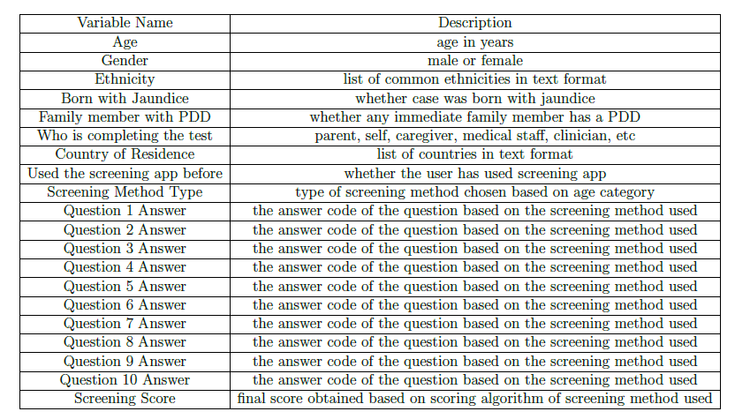

Table 1: List of Attributes[12] in ASD dataset.

For questions 1-9: if you circle an answer in columns C, D or E, score 1 point per question. For question 10: if you circle an answer in columns A, B or C, score 1 point. Add points together for all ten questions. If your child scores more than 3 out of 10, the health professional may consider referring your child for a multi-disciplinary assessment.

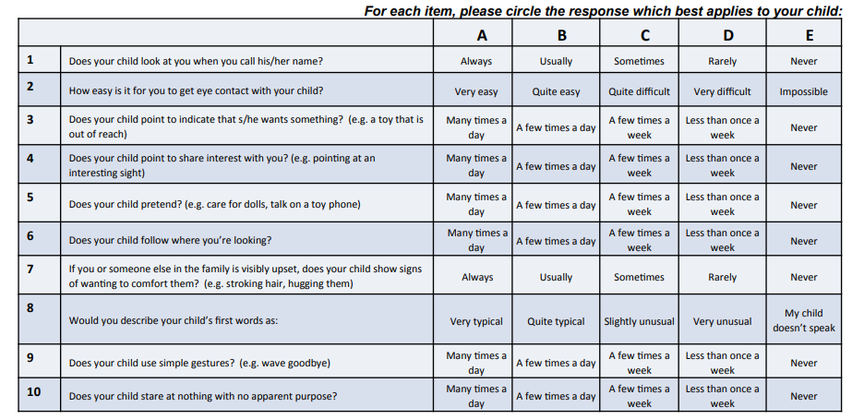

Table 2: Description[14] of AQ-10 Questions.

**5.2 Data Preprocessing**

Unfortunately, this data set does have a lot of invalid or missing entries that are represented with question marks. Thus, we must preprocess our data so it is ready to be used as input for machine learning algorithms. Here, we begin, by replacing entries with the symbol “?” and convert them into ‘NAN' (not a number).

Next, we split the data into features and target label and normalize the numerical variables `age' and `result', using the MinMaxScaler feature in Python. For the categorical variables we use the one-hot encoding scheme. This results in 94 total features after one-hot encoding. Additionally, we need to convert the non-numeric target variable ‘Class/ASD’ to numerical values for the learning algorithm to work. Since there are only two possible categories for this label (‘yes’ or ‘no’), we can avoid using one-hot encoding and simply encode these two categories as 0 and 1, respectively.

**5.3 Algorithms and Techniques**

We have used several machine learning classification techniques to detect the Autism Spectrum Disorder namely:

• Decision Trees

• Random Forests

• Support Vector Machines (SVM)

• k-Nearest Neighbors (kNN)

• Logistic Regression

• Multi-Layer Perceptron (MLP)

**5.3.1 Decision Tree:**

We will begin with creating a Decision Tree Classifier, also known as ID3 Algorithm and fit our training data. A Decision Tree uses a tree structure to represent a number of possible decision paths and an outcome for each path. They can also perform regression tasks and they form the fundamental components of Random Forests which will be applied to this dataset in the next section.

Decision Tree models are easy to use, run quickly, are able to handle both categorical and numerical data, and graphically allow you to interpret the data. Further, we don't have to worry about whether the data is linearly separable or not.

**5.3.2 Random Forest**

One way of avoiding overfitting that Decision Trees are prone to, is to apply a technique called Random Forests, in which we build multiple decision trees and let them vote on how to classify inputs. Random forests (or random decision forests) are an ensemble learning method for classification, regression and other tasks, that operate by constructing a multitude of decision trees at training time and outputting the class that is the mode of the classes (classification) or mean prediction (regression) of the individual trees. Random decision forests correct for decision trees' habit of overfitting to their training set.

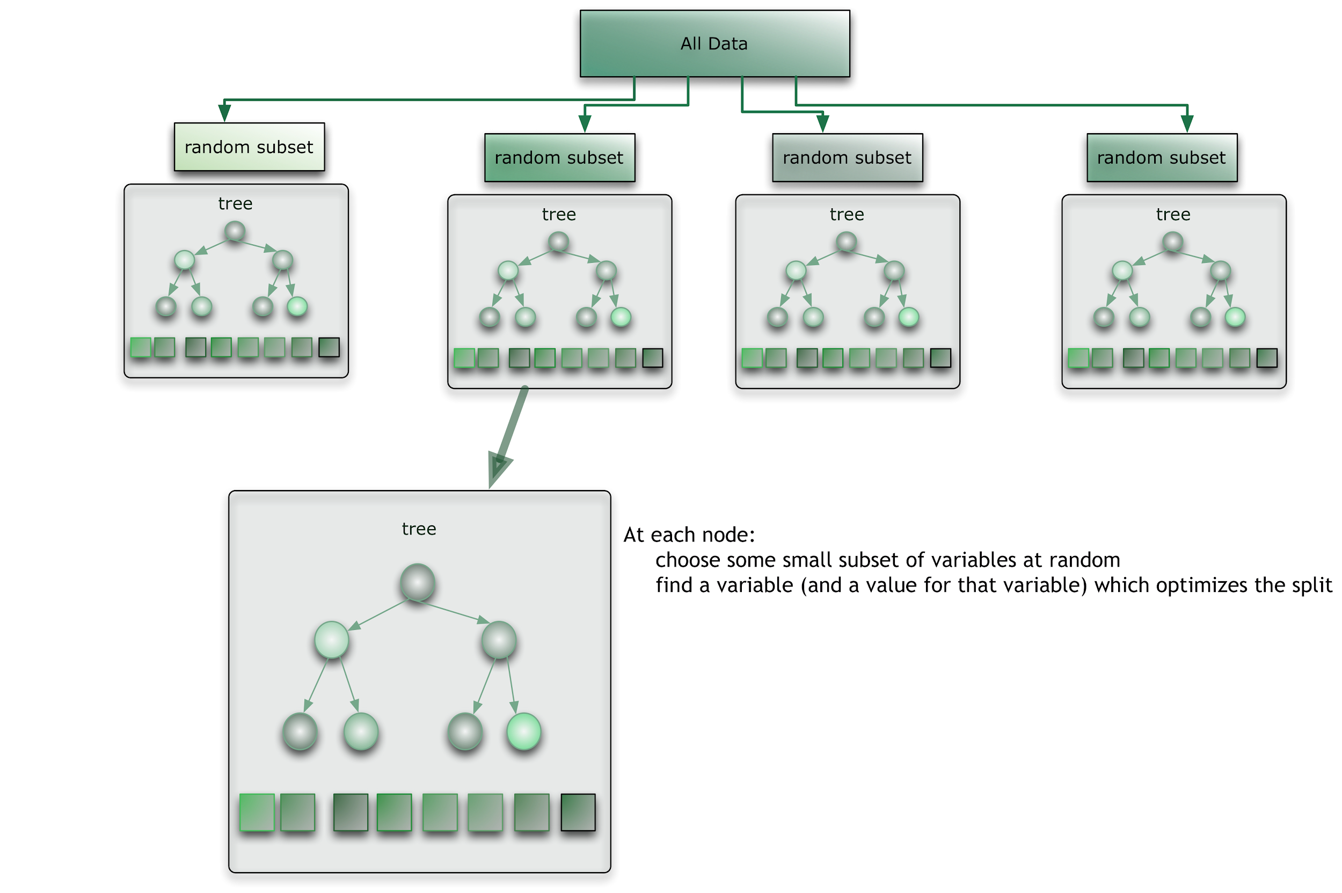

**Fig. 1 Random Forest Diagram[12]**

**5.3.3 Support Vector Machine(SVM)**

Support Vector Machine is a supervised machine learning algorithm that is commonly used in classification problems. It is based on the idea of finding the hyperplane that `best' splits a given data set into two classes. The algorithm gets its name from the support vectors (the data points closest to the hyperplane), which are points of a data set that if removed would alter the position of the separating hyperplane.

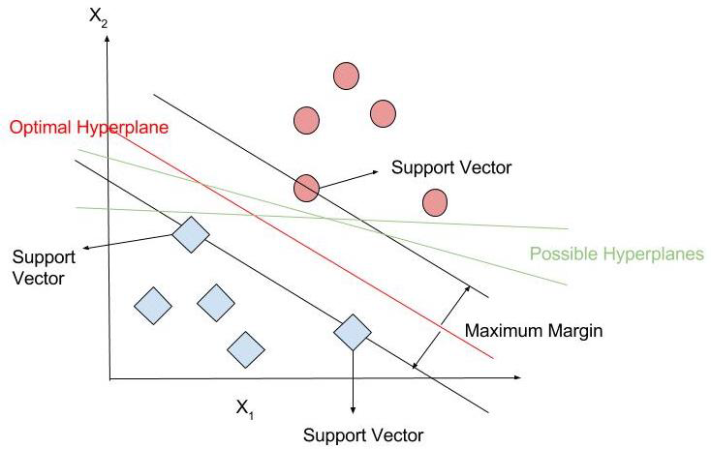

**Fig. 2 Support Vector Machine Diagram[12]**

The distance between the hyperplane and the nearest training data point from either set is known as the margin. Mathematically, the SVM algorithm is designed to find the hyperplane that provides the largest minimum distance to the training instances.

**5.3.4 k-Nearest Neighbour(kNN)**

The k Nearest Neighbor (kNN) algorithm is based on mainly two ideas: the notion of a distance metric and that points that are close to one another are similar.

Let x be the new data point that we wish to predict a label for. The k Nearest Neighbor algorithm works by nding the k training data points x1; x2; xk closest to x using a Euclidean distance metric. kNN algorithm then performs majority voting to determine the label for the new data point x. In the case of binary classification it is customary to choose k as odd.

**5.3.5 Logistic Regression**

The goal of logistic regression is to nd the best fitting model to describe the relationship between the dichotomous characteristic of interest (dependent variable = response or outcome variable) and a set of independent (predictor or explanatory) variables.

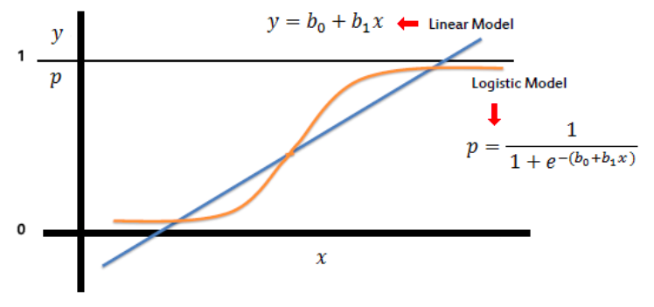

**Fig. 3 Logistic Regression Model[12]**

Logistic regression can be called as binary classification problems. A key point to note here is that Y can have 2 classes only and not more than that. If the response variable has more than 2 classes, it would become a multi class classification. Yet, Logistic regression is a classic predictive modelling

technique and still remains a popular choice for modelling binary categorical variables. Another advantage of logistic regression is that it computes a prediction probability score of an event.

**5.3.6 Multi-Layer Perceptron(MLP)**

A multilayer perceptron (MLP) is a class of feedforward artificial neural network. An MLP consists of at least three layers of nodes. Neural networks use the ability of the perceptrons to represent elementary functions and combine them in a network of layers of elementary questions.

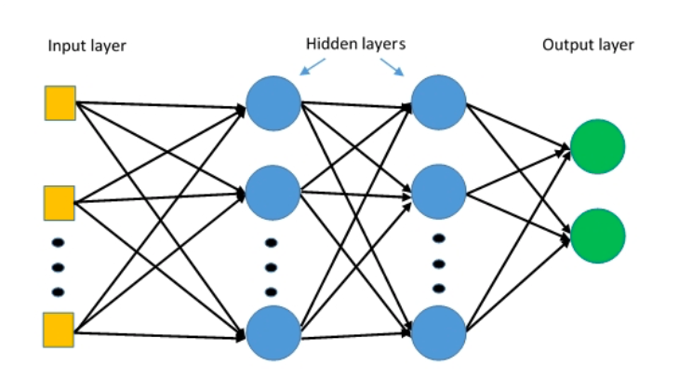

**Fig. 4 MLP Architecture[12]**

**6. Software and Hardware Requirements**

Software: Anaconda(jupyter Notebook)

Jupyter Notebook should be installed with following Libraries:

* Python
* Numpy
* Pandas
* Matplotlib and Seaborn
* Scikit-Learn
* Tensorflow with Keras

**7. Implementation**

Here, we split the given data into two parts. 80% of the data will be used to train the model and this data will be referred to as the training data set and 20% of the data will be reserved for testing the accuracy and effectiveness of the model on data that the model has never seen before and will be referred as the testing data set.

**7.1 Cross Validation**

Cross-validation is a model validation technique for assessing how the results of a machine learning algorithm will generalize to an unseen data set. The goal of cross validation is to define a dataset to “test” the model in the training phase in order to limit problems like underfitting or overtting, and give an insight on how the model will generalize to an independent unknown dataset.

**7.2 k-Fold Cross Validation**

One of the disadvantages in performing cross-validation is that we lose quite a bit of data that could have been used to train the model and thus possibly arrive at more correct predictions. In a traditional train-test split, the error metric can have high variance, i.e., the error may depend heavily on which data points end up in the training set and which end up in the test set, and thus the evaluation may be significantly different depending on how the division is made. To overcome these difficulties, another popular technique for model assessment with the same flavor as cross-validation but slight variation is called k-Fold Cross Validation is used.

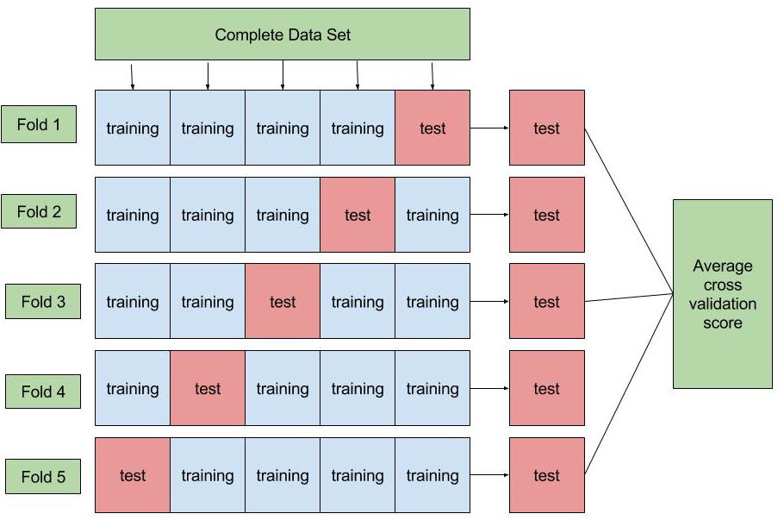

**Fig. 5 k-fold Cross Validation**

Since we preprocessed the ASD dataset, we didn't run into any problems or difficulties. To implement each of the mentioned methods, we imported and used the following Python modules from Scikit Learn.

* from sklearn.tree import DecisionTreeClassifier
* from sklearn.ensemble import RandomForestClassifier
* from sklearn import svm
* from sklearn import neighbors
* from sklearn.naive_bayes import MultinomialNB
* from sklearn.linear_model import LogisticRegression
* from sklearn.discriminant_analysis import LinearDiscriminantAnalysis
* from keras.models import Sequential
* from keras.layers import Dense, Dropout, Activation

To calculate the desired metrics I imported and used the following Python modules:

* from sklearn.cross_validation import cross_val_score

cross_val_score(*,features_final,asd_classes,cv=10,scoring='roc_auc').mean()

* from sklearn.metrics import fbeta_score
* from sklearn.model_selection import cross_val_score

clf = Classifier(random_state=1)

cv_scores = cross_val_score(clf, features_final, asd_classes, cv=10)

cv_scores.mean()

* model = Sequential()

model.add(Dense(8, activation='relu', input_dim= 94))

model.add(Dropout(0.2))

model.add(Dense(1, kernel_initializer='normal', activation='sigmoid'))

model.summary()

score = model.evaluate(X_test, y_test, verbose=0)

**8. Results**

In this section, we present the numerical results from different machine learning algorithms applied to our ASD data set. In all these numerical computation, I used SciKit Learn module which is written in Python.

**8.1 Visualization of different ML techniques result**

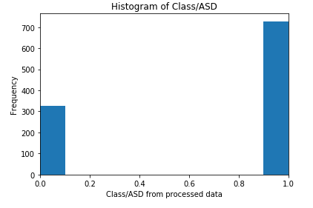

**Fig. 6 Histogram of Class/ASD**

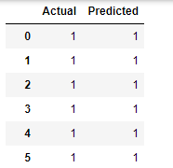

**Fig. 7 Predicted Result After Applying Decision Tree**

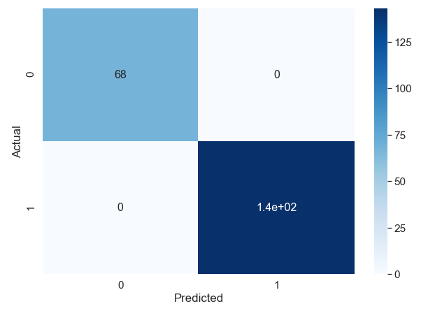

**Fig.8 Confusion matrix for Decision Tree**

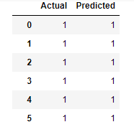

**Fig.9 Predicted Result After applying Random Forest**

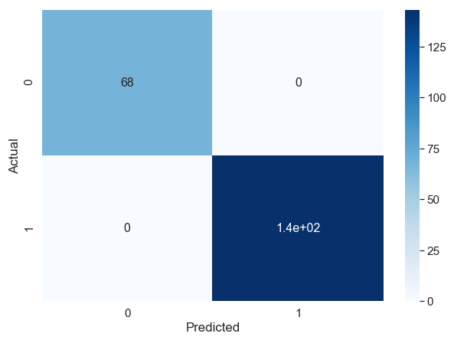

**Fig. 10 Confusion Matrix for Random Forest**

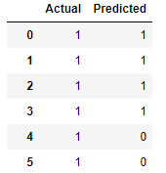

**Fig. 11 Predicted Result After applying k-NN**

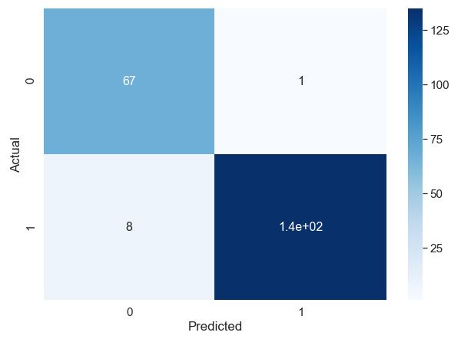

**Fig.12 Confusion Matrix for K-Nearest Neighbors**

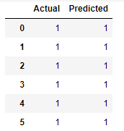

**Fig.13 Predicted Result after applying Logistic Regression**

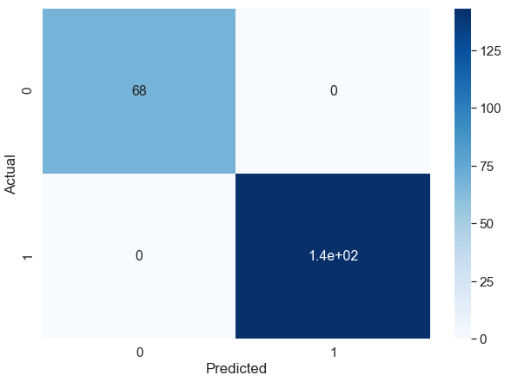

**Fig. 13 Confusion Matrix for Logistic Regression**

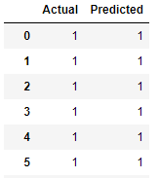

**Fig. 14 Predicted Result after applying Support Vector Machine**

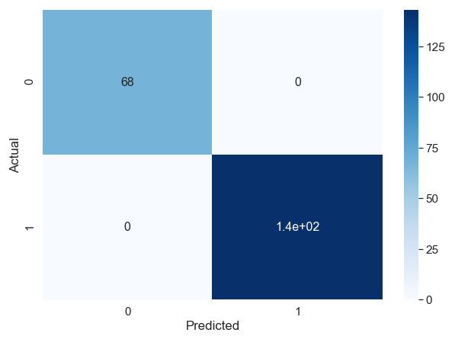

**Fig.15 Confusion Matrix for Support Vector Machine**

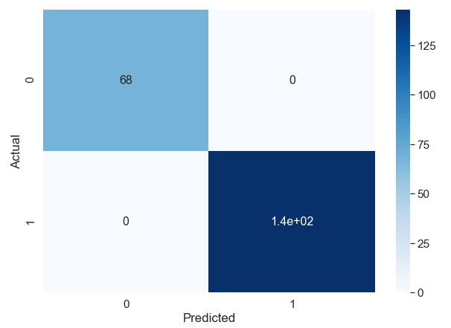

**Fig. 16 Confusion Matrix for Multi-Layer Perceptron Model**

**8.2 Model Evaluation and Performance**

After exploring the ASD dataset with different learning algorithms, we have arrived at the conclusion that all of our model work extremely well with the data. we have used three different metrics (accuracy, Precision and F-score) to measure the performance of the models, and it seems like all of the metrics indicated an almost perfect classification of the ASD cases.

|  |  |  |  |
| --- | --- | --- | --- |
| Learning Algorithm | Training Accuracy | Testing Accuracy | Final Parameters |
| Decision Tree | 1.0 | 1.0 | default |
| Random Forest | 1.0 | 1.0 | n-estimators=5, random-state=1 |
| SVM | 1.0 | 1.0 | kernel=’linear’ |
| KNN | 0.967 | 0.957 | k=5 |
| Logistic Regression | 0.997 | 0.995 | default |
| Multi-Layer Perceptron | 0.9976 | 0.9952 | epoch=100 |

**Table 3: comparison of metrics using different learning algorithms**

Looking over the Table 3, it is abundantly clear that the SVM algorithm with a linear kernel does the best job in classifying new instances into one of two categories:“ patient has ASD” and “patient does not have ASD”. Hence we should consider SVM as our final model, with the Logistic Regression and Random Forest being a close second. On the other hand the K nearest Neighbors classifier would not be the method of choice for prediction of new instances given the previously discussed disadvantages of the method and the metric performances that can be observed from Table 3.

**8.2 Comparison of Accuracy of ML Algorithms**

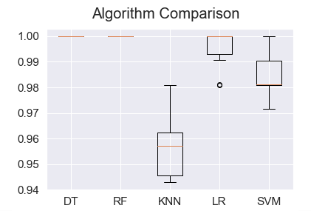

**Fig. 17 Comparison of Accuracy of ML algorithms using Boxplot**

**9. Conclusions**

To summarize, we set out with the hopes of applying machine learning algorithms, specifically, supervised machine learning techniques that can classify new patients (new instances) with certain measurable characteristics (the variables) into one of two categories “patient has ASD” or “patient does not have ASD”.

we were able to build such models and found that the algorithm that performs the best in all aspects is the SVM machine learning algorithm, using a ‘linear kernel’. The SVM outperformed all other models with respect to cross-validation score, AUC Score, and F-Beta Score, all scores were 1, and thus was as good as our benchmark model.

Although the data association made the prediction very simple, but we feel this work can certainly serve as an invaluable aid for physicians for detection of new autistic cases. In our consideration, to build an accurate and robust model, one needs to have larger datasets. Here the number of instances after cleaning the data were not sufficient enough to claim that this model is optimum. Looking at the performances of our learning models, nothing can be improved with this current data set as models are already at their best.

**10. References**

[1] Kayleigh K. Hyde. Applications of Supervised Machine Learning in Autism Spectrum Disorder Research: a Review. Review Journal of Autism and Developmental Disorders (2019) 6:128–146.

[2] Andrea Zunino. Video Gesture Analysis for Autism Spectrum Disorder Detection. Conference Paper September 2018.

[3] Guobin Wan. Applying Eye Tracking to Identify Autism Spectrum Disorder in Children. Journal of Autism and Developmental Disorders (2019) 49:209–215.

[4] Mirac Baris Usta. Use of machine learning methods in prediction of short-term outcome in ASD. Published by Informa UK Limited, trading as Taylor & Francis Group.

[5] Qandeel Tariq. Detecting Developmental Delay and Autism Through Machine Learning Models Using Home Videos of Bangladeshi Children. JOURNAL OF MEDICAL INTERNET RESEARCH

[6] Scott H. Lee, Matthew J. Maenner. A comparison of machine learning algorithms for the surveillance of autism spectrum disorder. Centers for Disease Control and Prevention, Atlanta, GA, United States of America.

[7]. Amirreza Rouhi, Micol Spitale, Fabio Catania, Giulia Cosentino, Mirko Gelsomini, Franca Garzotto, "Emotify: Emotional Game for Children with Autism Spectrum Disorder based-on Machine Learning," IUI ’19 Companion, March 17–20, 2019, Marina del Rey, CA, USA.

[8] Murat Gok. A novel machine learning model to predict autism spectrum disorders risk gene.

[9] Elizabeth Stevens, Dennis R. Dixon. Identification and analysis of behavioral phenotypes in autism spectrum disorder via unsupervised machine learning. International Journal of Medical Informatics 129 (2019) 29–36.

[10] Kazi Shahrukh Omar. A Machine Learning Approach to Predict Autism

Spectrum Disorder. 2019 International Conference on Electrical, Computer and Communication Engineering (ECCE), 7-9 February, 2019.

[11] Zhong Zhao. Applying Machine Learning to Identify Autism With Restricted Kinematic Features. IEEE Access Received October 10, 2019, accepted October 24, 2019, date of publication October 29, 2019, date of current version November 8, 2019.

[12] Autism detection in Adults. <https://github.com/kbasu2016>.

[13] Autism detection using classification in Machine Learning. https:// github.com/tanmayjain93.

[14][https://www.autismalert.org/uploads/PDF/SCREENING-AUTISM-QCHAT-10%20Question%20Autism%20Survey%20for%20Toddlers.pdf](https://www.autismalert.org/uploads/PDF/SCREENING--AUTISM--QCHAT-10%20Question%20Autism%20Survey%20for%20Toddlers.pdf)

[15]Tabtah, F. (2017). Autism Spectrum Disorder Screening: Machine Learning Adaptation and DSM-5 Fulfillment. Proceedings of the 1st International Conference on Medical and Health Informatics 2017, pp.1-6. Taichung City, Taiwan, ACM.